

Football Monk
A PROJECT REPORT
Advance Internet Programming
Subject Code: 26CAH-614

Submitted By: Submitted To:
Name: Ashutosh Dash Name: Ms. Tanisha
UID: 26MCD10089 Designation: Assistant Professor
Class: 26MCD-2 Ecode:E20679
Section: A

Master of Computer Applications – (Data Science)
University Institute of Computing
Chandigarh University,
Gharuan, Mohali, Punjab, India-140413

BONAFIDE CERTIFICATE
Certified that this project report "Football Monk" is the bonafide work of "Ashutosh Dash, UID: 26MCD10089" who carried out the project work under my/our supervision. The content and findings presented herein are authentic and reflect the original work conducted during the course of this project.
SIGNATURE  Name: Ashutosh Dash  UID : 26MCD10089  Department : MCD – 2/A | SIGNATURE  Name: Tanisha Bansal  Designation: Asst. Professor  Ecode: E20769
Submitted for the project viva-voce examination held on

ACKNOWLEDGEMENT
I would like to express my sincere gratitude to everyone who contributed to the successful completion of this mini project. Developing a complete web application with Servlets, JSP and JDBC was a valuable learning experience, and I am grateful for the guidance and support I received along the way.
I extend my heartfelt thanks to Ms. Tanisha Assistant professor MCA, for the encouragement and the academic environment that made this work possible. University Institute of Computing, whose guidance, expertise and willingness to clear my doubts were instrumental in completing this project.
I also thank all the faculty members of the department for their valuable suggestions, and friends for their constant motivation and support.
[Ashutosh Dash]
UID: 26MCD10089

ABSTRACT
Football shops, clubs and academies that still keep their jersey stock in paper registers or loosely maintained spreadsheets find it hard to track which team, player, size and price are available, search quickly and control who can change the records. This project presents a web-based Football Jersey Management System (JerseyMS) that lets an authorised admin log in, view the complete jersey stock, search by team or player, and add, edit or delete jersey records.
The application is developed in Java using the Jakarta EE stack: Servlets act as controllers, JSP pages with JSTL form the views, and JDBC connects the application to a MySQL database. The design follows the Model–View–Controller pattern with a Data Access Object (DAO) layer, a servlet filter that protects every stock page behind a session-based login, and parameterised SQL queries (PreparedStatement) that guard against SQL injection. The project is built with Maven, developed in NetBeans and version-controlled on GitHub. The result is a lightweight, easy-to-deploy system that can be extended into a complete football merchandise management solution.

TABLE OF CONTENTS
Acknowledgement and Abstract 3
CHAPTER 1: INTRODUCTION 5
1.1 Project Scope and Project Planning 5
1.2 Client Identification and Recognition of Need 5
1.3 Recognition and Knowledge of Relevant Contemporary Issues 5
1.4 Task Identification 5
1.5 Technologies Used 6
1.6 Timeline of the Project 6
CHAPTER 2: LITERATURE REVIEW / BACKGROUND STUDY 6
2.1 Existing Solutions 6
2.2 Review Summary 6
2.3 Problem Definition 6
2.4 Goals / Objectives 6
CHAPTER 3: DESIGN FLOW / PROCESS 7
3.1 Evaluation and Selection of Features 7
3.2 Design Constraints 7
3.3 Design Flow 7
3.4 Database Design 7
3.5 Implementation Plan / Methodology 7
CHAPTER 4: IMPLEMENTATION, RESULTS ANALYSIS AND VALIDATION 8
CHAPTER 5: CONCLUSION AND FUTURE WORK 14
REFERENCES 15
APPENDIX: GITHUB REPOSITORY SCREENSHOTS 15
LIST OF FIGURES
Fig 3.1: Architecture and request flow of JerseyMS 7
Fig 4.1: pom.xml (Maven configuration) 8
Fig 4.2: DBConnection.java (JDBC connection) 8
Fig 4.3: Jersey.java (model class) 9
Fig 4.4: JerseyDAO.java 9
Fig 4.5: UserDAO.java 10
Fig 4.6: AuthFilter.java 10
Fig 4.7: LoginServlet.java 10
Fig 4.8: JerseyServlet.java 11
Fig 4.9: LogoutServlet.java 11
Fig 4.10: login.jsp 11
Fig 4.11: jerseys.jsp 12
Fig 4.12: jerseyForm.jsp 12
Fig 4.13: index.jsp 12
Fig 4.14 – 4.16: Output screens: login, jersey list, add/edit form 13
Fig A.1 – A.2: GitHub repository and push screenshots 15

CHAPTER 1.
INTRODUCTION
Football jerseys come in many combinations of team, player, number and size, yet many small shops still keep stock records in registers or spreadsheets. Manual record keeping is slow and error-prone, and it makes simple questions hard to answer: Is this player’s jersey in stock? Which sizes are left, and at what price? The Football Jersey Management System (JerseyMS) developed in this mini project replaces such records with a secure, browser-based web application.
JerseyMS allows an authorised admin to log in, view the complete jersey stock, search jerseys by team or player name, and add, edit or delete jersey records. It is built with the server-side Java technologies covered in the AIP subject: Servlets for control logic, JSP and JSTL for presentation and JDBC for database access, organised using the Model–View–Controller (MVC) and Data Access Object (DAO) patterns. The source code is hosted on GitHub: https://github.com/ashutoshdash8/JerseyMS.

1.1. Project Scope and Project Planning
The scope of the project covers the development and deployment of a web application that manages the jersey stock of a football store or club. Within scope are admin login and logout, session-based protection of all stock pages, listing and searching of jerseys, and full create–read–update–delete (CRUD) operations on jersey records. Customer accounts, ordering, billing and payment are outside the scope of this mini project and are listed under future work.
Project planning involves the following phases:
- Requirement analysis: Understanding what the admin needs and fixing the feature list.
- Database design: Designing the users and jerseys tables in MySQL.
- Model and DAO development: Writing the Jersey model, DBConnection utility and the DAO classes.
- Controller development: Implementing the login, jersey and logout servlets and the authentication filter.
- View development: Creating index.jsp, login.jsp, jerseys.jsp and jerseyForm.jsp with JSTL.
- Testing and documentation: Testing every flow, uploading the project to GitHub and preparing this report.

1.2. Client Identification and Recognition of Need
The primary client is the store or club admin, who maintains the jersey stock every day. Fans and club staff are indirect beneficiaries because an accurate and searchable stock list helps them find the required jersey faster, and the management benefits from reliable stock and price records. The admin needs a tool that is quick to use, available from any browser, protected by a login, and able to keep the team, player, number, size, price and quantity of every jersey up to date. JerseyMS is designed around exactly these needs.

1.3. Recognition and Knowledge of Relevant Contemporary Issues
Digitisation of retail and sports services is a major contemporary trend, and shops are expected to provide quick, searchable and reliable stock records. Alongside convenience, security is a key concern. Common web risks include SQL injection, weak password storage and unauthorised access to administrative pages. JerseyMS addresses these in a practical way: SQL statements use PreparedStatement parameters, an AuthFilter blocks any request to the stock pages without a valid login session, forms validate input, and deleting a record asks for confirmation. Password hashing is listed as future work.

1.4. Task Identification
- Database: Create the jerseydb database with the users and jerseys tables.
- Back end: Implement DBConnection, the Jersey model, JerseyDAO and UserDAO.
- Controllers: Implement LoginServlet, JerseyServlet, LogoutServlet and AuthFilter.
- Front end: Build the login page, jersey list with search, and the shared add/edit form.
- Testing and delivery: Verify login, search, add, edit, delete and logout, then upload to GitHub.

1.5. Technologies Used
Layer | Technology | Purpose
Language | Java 17 | Application logic (maven.compiler.source/target = 17)
Controller | Jakarta Servlet / Filter (Jakarta EE 10) | Request handling, authentication filter
View | JSP with JSTL 3.0 | Dynamic HTML pages, loops and safe output
Database | MySQL, Connector/J | Persistent storage accessed through JDBC
Build tool | Apache Maven (WAR packaging) | Dependency management and build
Server | Jakarta EE 10 servlet container (e.g., Apache Tomcat 10+) | Runs the deployed WAR file
IDE / VCS | NetBeans, Git and GitHub | Development, version control, hosting

1.6. Timeline of the Project
Phase | Activity | Duration
Phase 1 | Planning, requirement analysis and database design | Week 1
Phase 2 | Model, DBConnection and DAO classes | Week 1 – 2
Phase 3 | Servlets, filter and JSP views | Week 2 – 3
Phase 4 | Testing, GitHub upload and report writing | Week 3

CHAPTER 2.
LITERATURE REVIEW / BACKGROUND STUDY

2.1. Existing Solutions
Stores currently use a range of solutions, each with its own strengths and limitations:
- Paper registers and spreadsheets: Simple and free, but searching is slow, duplicate entries are common and there is no access control or audit of changes.
- Open-source inventory software: Open-source inventory and point-of-sale tools are feature-rich, but they need installation and server administration skills and are too heavy for a small store or a learning project.
- Commercial software: Commercial inventory products offer complete modules, but licence and maintenance costs are high.
- The proposed approach: A small, secure and easy-to-understand web application built with standard Java EE technologies fills the gap between a spreadsheet and a full inventory suite, and doubles as a teaching example of layered web design.

2.2. Review Summary
The review shows that most small stores need a few core capabilities: a searchable stock list, accurate quantity and price records and restricted editing. The MVC pattern separates presentation from logic, and the DAO pattern isolates all SQL in one layer. PreparedStatement and session-based access control are well-established practices for protecting data in database-backed web applications. These ideas are combined in JerseyMS.

2.3. Problem Definition
To design and develop a secure, browser-based Football Jersey Management System that allows an authenticated admin to maintain the jersey stock (add, edit, delete, search and view jerseys) using Servlets, JSP and JDBC with a MySQL back end, while ensuring that unauthenticated users cannot access or modify the data.

2.4. Goals / Objectives
- Authentication: Provide secure login and logout using HTTP sessions.
- Jersey management: CRUD operations on jerseys with team, player, number, size, price and quantity.
- Search: Let the user find a jersey by part of the team name or player name.
- Clean architecture: Keep JDBC code in DAO classes and keep JSP pages free of business logic.
- Safety: Protect against SQL injection, validate form input and confirm before deleting.

CHAPTER 3.
DESIGN FLOW / PROCESS

3.1. Evaluation and Selection of Features
Features were selected on the basis of what an admin needs daily and what can be built reliably within the project time: login and logout, a protected jersey list, search by team or player, add and edit through one shared form, delete with a confirmation dialog, and form validation (required fields, jersey number 1 to 99, non-negative price and quantity). Customer orders and billing were deferred.

3.2. Design Constraints
The project was designed within the following constraints: only core Jakarta EE technologies (no Spring or Hibernate) as required by the subject; a single user role (admin); a local MySQL database; a Jakarta EE 10 servlet container, because the jakarta.* package names are not supported by older Java EE 8 servers; and a limited project duration.

3.3. Design Flow
Every request to the stock pages first reaches the AuthFilter. If a valid session is present the request continues to JerseyServlet, otherwise the user is redirected to /login. Servlets call the DAO classes, which obtain a connection from DBConnection and run parameterised SQL on MySQL; the results are forwarded to the JSP views.
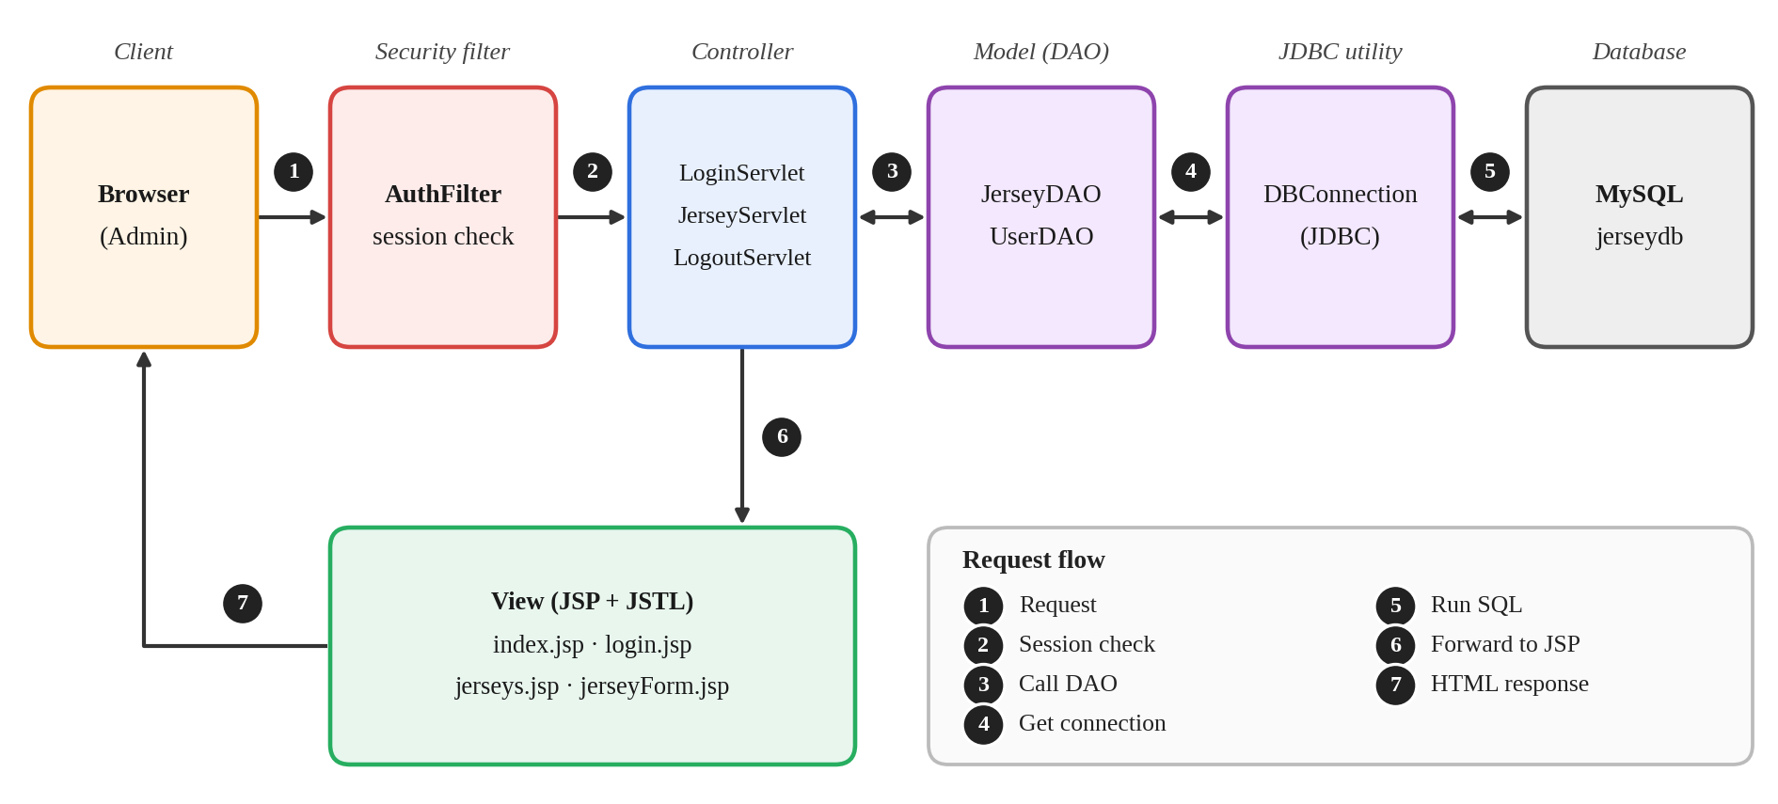
Fig 3.1: Architecture and request flow of JerseyMS

3.4. Database Design
Table | Columns | Remarks
users | id, username, password | Admin credentials, checked with a PreparedStatement
jerseys | id, team_name, player_name, jersey_number, size, price, quantity | id is the key; search uses LIKE on team and player

3.5. Implementation Plan / Methodology
The system is implemented bottom-up: database and connection first, then the model and DAO classes, then the servlets and filter, and finally the JSP views. Each layer is tested before the next is added. The project is packaged as a WAR file with Maven and deployed on the servlet container.

CHAPTER 4.
IMPLEMENTATION, RESULTS ANALYSIS AND VALIDATION
This chapter presents the implementation layer by layer. Every figure is a screenshot of the actual source code of the project (package com.aip.jersey).

4.1. Build Configuration and Database Connectivity
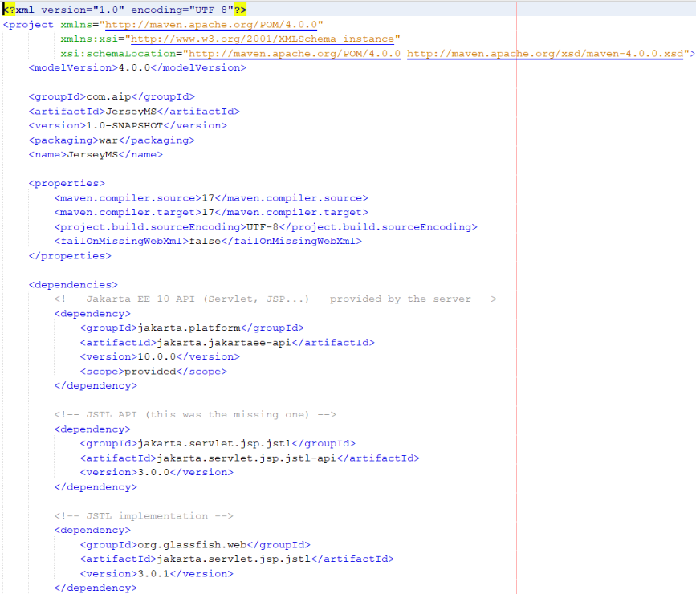
Fig 4.1: pom.xml (Maven configuration)

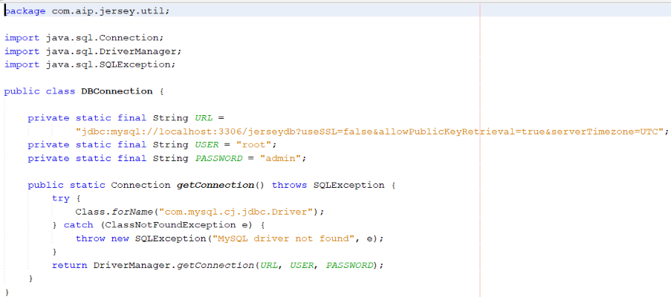
Fig 4.2: DBConnection.java

4.2. Model Layer
Jersey is a plain Java class (POJO) with id, teamName, playerName, jerseyNumber, size, price and quantity, a default and a parameterised constructor, and getters/setters used by the JSP expression language.
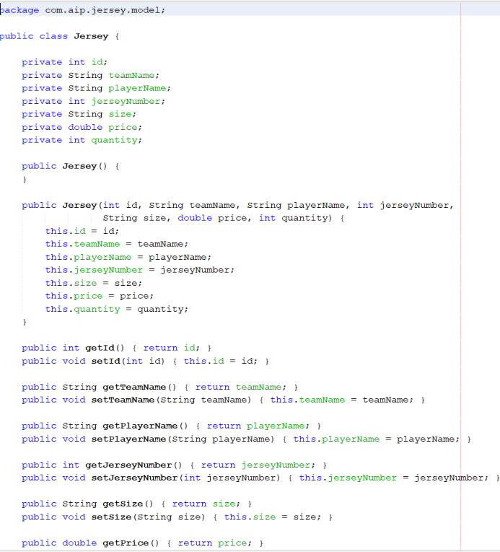
Fig 4.3: Jersey.java

4.3. Data Access Layer
JerseyDAO maps each database row to a Jersey object. getAll() returns every jersey ordered by id, search(keyword) runs a parameterised LIKE query on team_name and player_name, and further methods fetch, add, update and delete a single jersey. UserDAO.validate() checks the username and password with a parameterised query and returns true when a matching user exists.
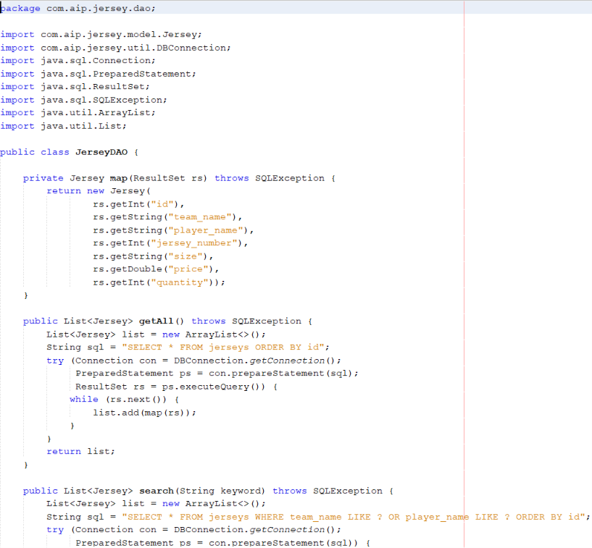
Fig 4.4: JerseyDAO.java
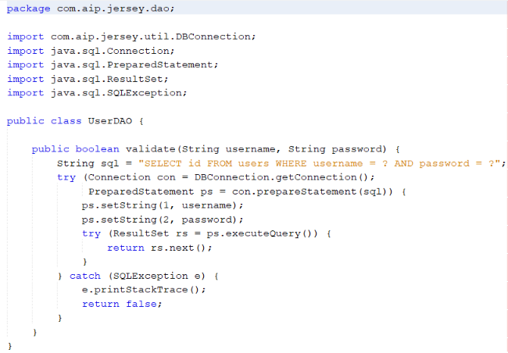
Fig 4.5: UserDAO.java

4.4. Security Filter
AuthFilter is mapped to /jerseys, /jerseys.jsp and /jerseyForm.jsp. It looks for the "user" attribute in the session and redirects to /login when it is missing.
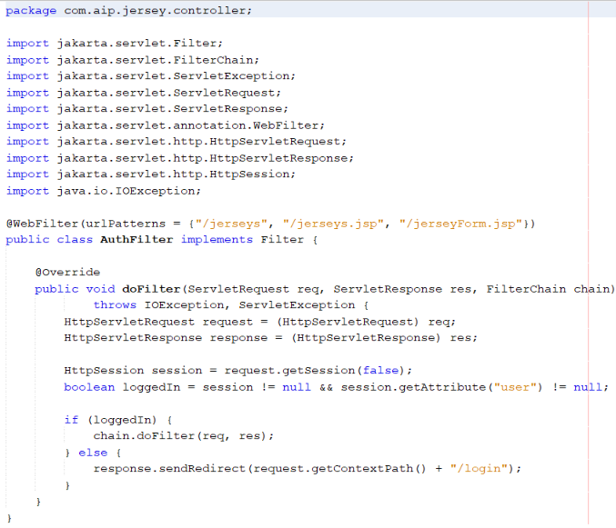
Fig 4.6: AuthFilter.java

4.5. Controller Layer
LoginServlet shows the login page (GET) and validates credentials (POST), storing the username in the session and redirecting to /jerseys on success. JerseyServlet reads the action parameter to forward to the add form, the edit form, delete a record or show the searchable list.
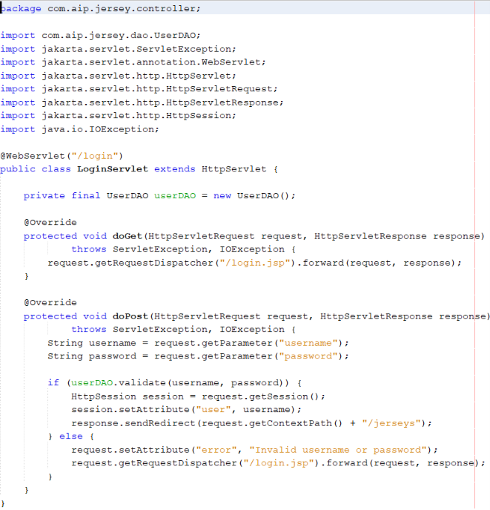
Fig 4.7: LoginServlet.java
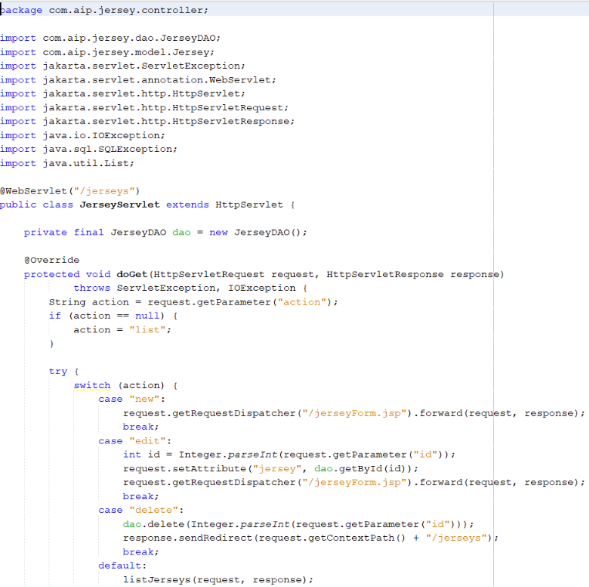
Fig 4.8: JerseyServlet.java

LogoutServlet invalidates the session and redirects the user back to the login page.
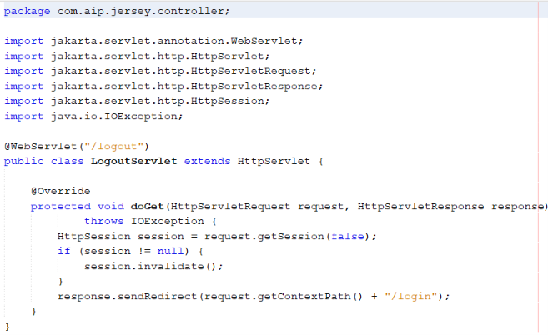
Fig 4.9: LogoutServlet.java

4.6. View Layer
login.jsp posts to /login and shows any error message. jerseys.jsp lists the jerseys using JSTL c:forEach, with search, Edit, Delete (with a confirm dialog) and Logout controls. jerseyForm.jsp is shared by Add and Edit, and index.jsp is the home page with links to the admin login and the jersey list.
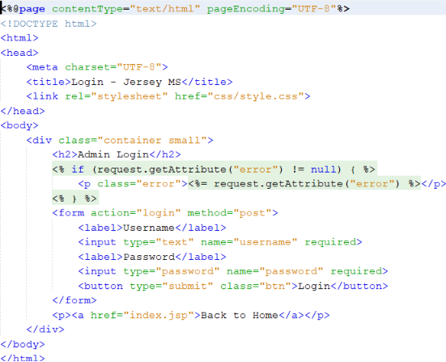
Fig 4.10: login.jsp
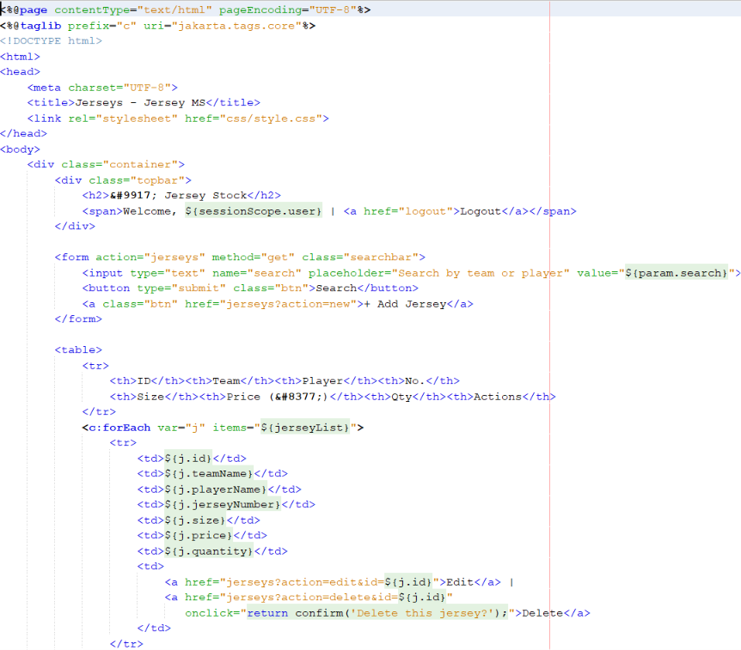
Fig 4.11: jerseys.jsp

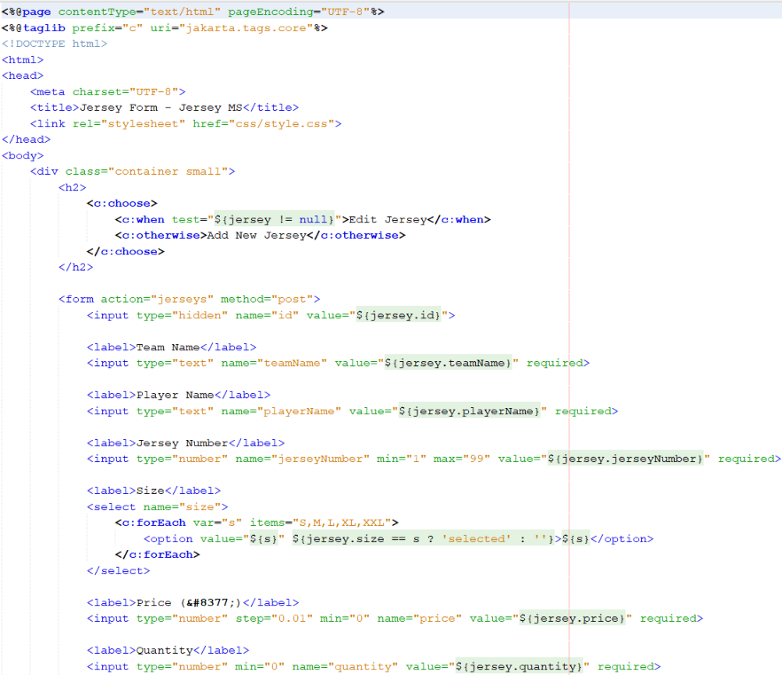
Fig 4.12: jerseyForm.jsp
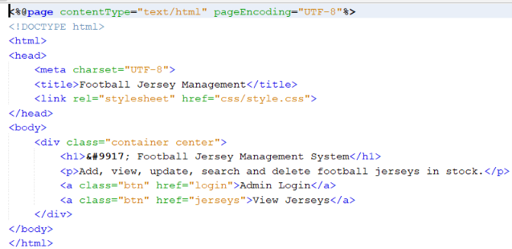
Fig 4.13: index.jsp
4.7. Output Screen 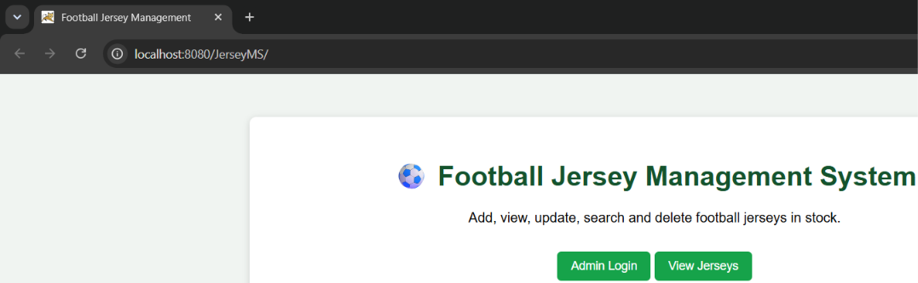 Fig 4.14: login page

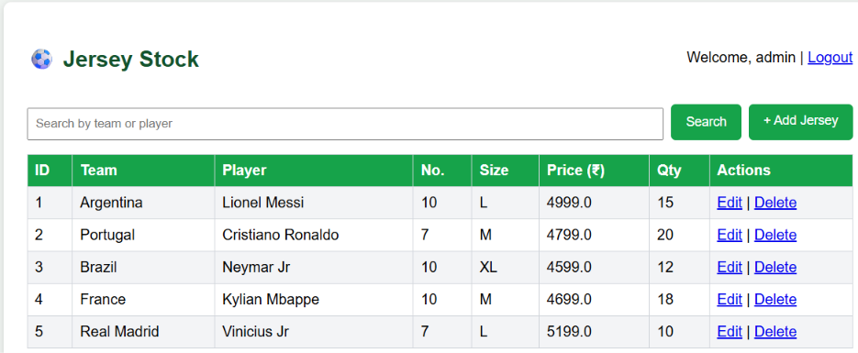

Fig 4.15: jersey list and search

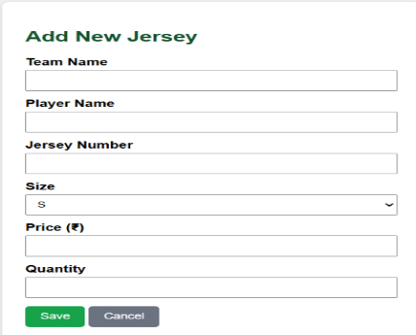

Fig 4.16: Add/Edit jersey form

4.8. Test Cases and Validation
The following test cases were prepared from the implemented logic to validate the main flows of the system.
# | Test case | Input / action | Expected result
1 | Valid login | Correct username and password | Session is created and the user is redirected to /jerseys
2 | Invalid login | Wrong username or password | "Invalid username or password" is shown on the login page
3 | Direct access without login | Open /jerseys without a session | AuthFilter redirects to /login
4 | Search | Enter part of a team or player name | Only matching jerseys are listed
5 | Add jersey | Fill team, player, number, size, price, quantity and Save | New jersey appears in the list
6 | Edit jersey | Click Edit, change a value and Save | Updated values appear in the list
7 | Delete jersey | Click Delete and confirm | Jersey is removed; Cancel keeps the record
8 | Logout | Click Logout | Session is invalidated and /login is shown

CHAPTER 5.
CONCLUSION AND FUTURE WORK

5.1. Conclusion
The Football Jersey Management System meets its objectives: an admin can securely log in, search the jersey stock, and add, edit or delete jerseys through a simple web interface. Applying the MVC and DAO patterns kept the code organised, while PreparedStatement queries, a session filter and input validation provide a sound security baseline for a mini project.
REFERENCES
1. Eclipse Foundation, "Jakarta Servlet Specification, Version 6.1," Jakarta EE, 2025.
2. Eclipse Foundation, "Jakarta Server Pages Specification, Version 4.0," Jakarta EE, 2025.
3. Oracle Corporation, "MySQL Reference Manual," MySQL Documentation.
4. Oracle Corporation, "MySQL Connector/J 26.7 Developer Guide," MySQL Documentation.
5. The Apache Software Foundation, "Maven Getting Started Guide," Apache Maven Project.
6. D. Alur, J. Crupi and D. Malks, Core J2EE Patterns: Best Practices and Design Strategies, 2nd ed., Prentice Hall, 2003.
7. Project source code: https://github.com/ashutoshdash8/JerseyMS
APPENDIX

GitHub Repository: https://github.com/ashutoshdash8/JerseyMS
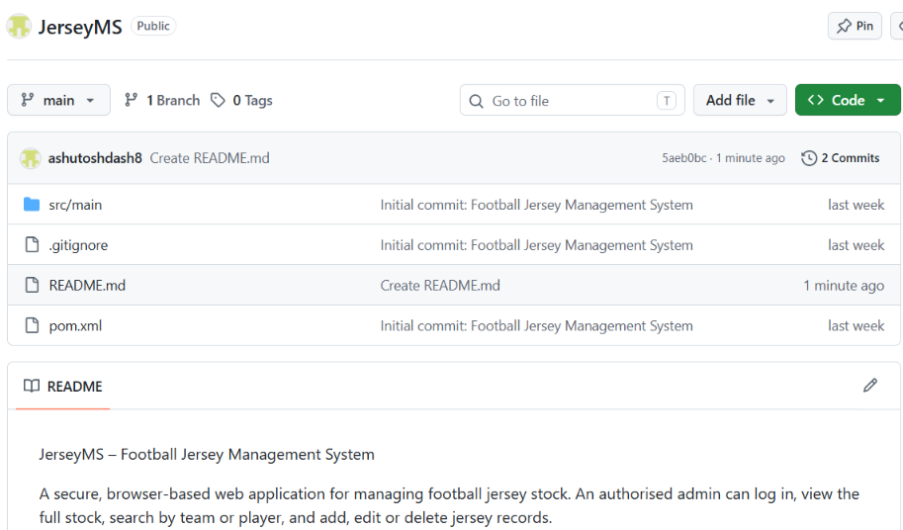
Fig A.1: Project uploaded on GitHub

